**DRIVER ANALYSIS**

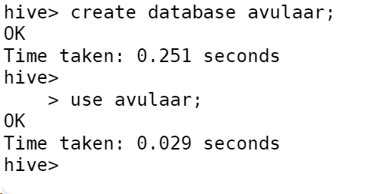

**Q1.How many total hours and miles logged by each driver**

**Q2.Print the name of the driver in the above query**

**Q3.Write the above query output in to hdfs director**

